|  |  |
| --- | --- |
| **Ex No: 3**  **Date: 20-08-2024** | **Building your Deep Neural Network** |

**Objective:**

To build and implement functions for a deep neural network, enabling efficient forward and backward propagation, accurate computation of the cost function, and effective parameter updates for training a model with multiple hidden layers.

**Descriptions:**

This project focuses on building a deep neural network capable of handling complex tasks such as image classification. The primary goal is to implement various essential components of a neural network, including initialization of parameters, forward propagation through multiple layers using both linear and non-linear (ReLU, Sigmoid) activations, and backward propagation for computing gradients necessary for parameter updates. By systematically developing functions to handle each part of the neural network, you will gain a deep understanding of how these elements work together to optimize model performance. This involves implementing the cost function to measure the model's performance, and updating parameters using gradient descent to minimize the cost. Ultimately, this project aims to equip you with the knowledge and tools to construct and train a deep neural network, laying the groundwork for applications in tasks like image classification and other machine learning challenges.

**Model architecture:**

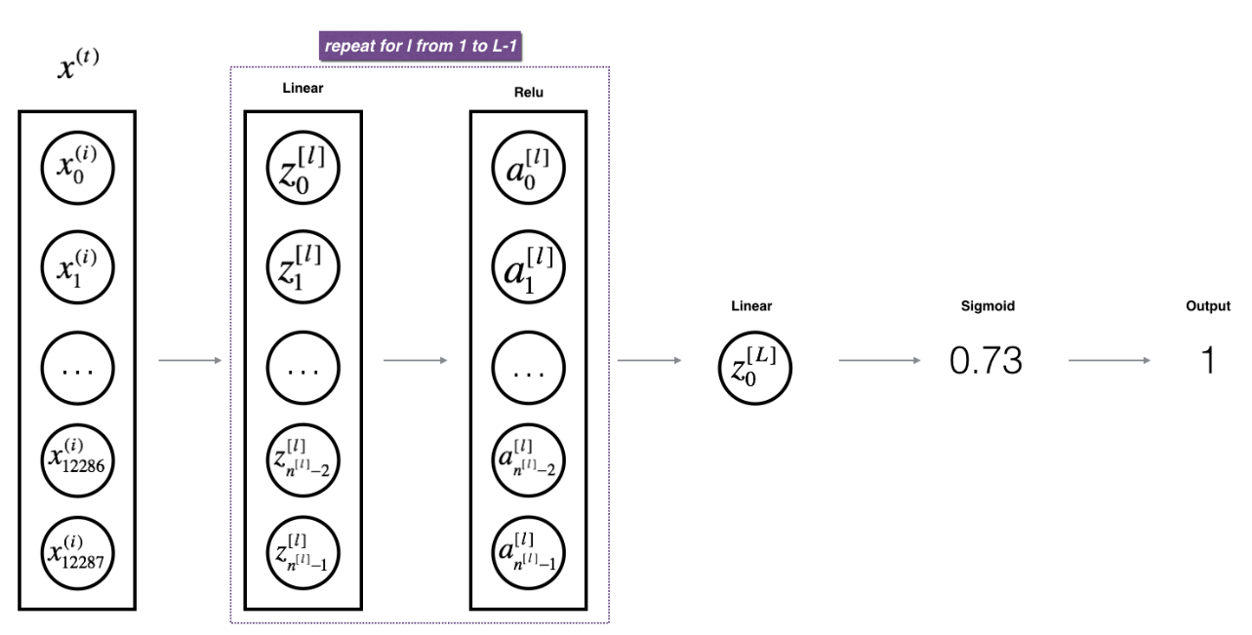

**Backpass Propogation**

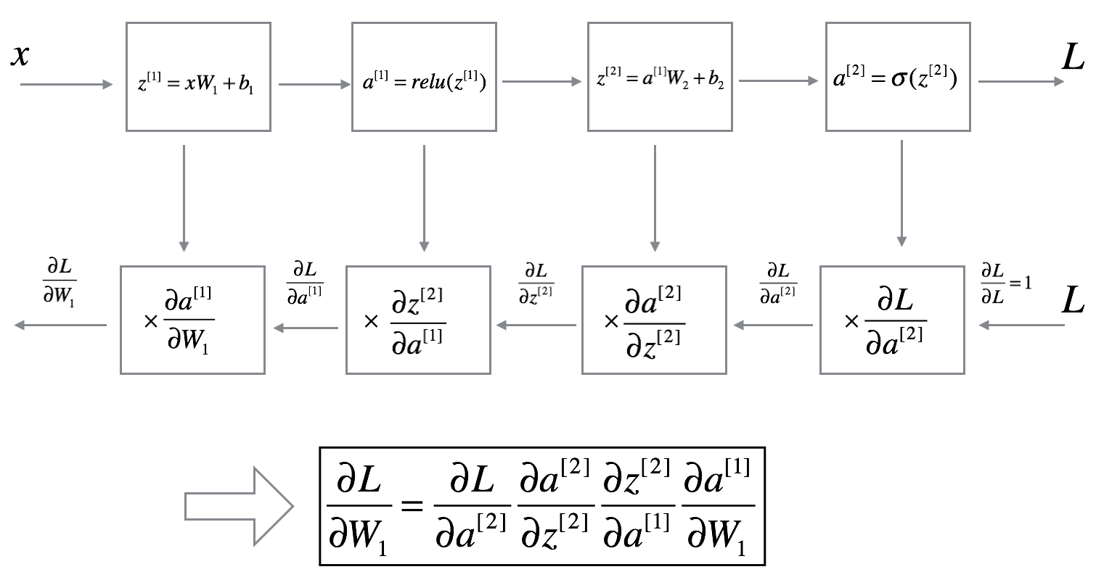

**GitHub Link:**

**https://github.com/Bhargava-Srinivasan-26/Deep_learning_elective/tree/main/Unit%201/Lab%203**